**1 INTRODUCTION**

* 1. Overview

Visual representation of airplane crash analysis

Comparing aboard vs fatalities vs ground

Maximum accidents based on years

Accidents happened in 1972 based on months

Highest number of accident happened by operators

Top 10 locations which had more accidents

Top 5 flights which have maximum accident history

Accidents based on regions

* 1. Purpose

In this project we have analyzed the causes of an

aviation accidents throughtout the world in different situations.

The outcome can be used to prevent future flight accidents by

taking various measures like annual surveillance programme,

accident prevention program.

2 PROBLEM DEFINITION AND DESIGN THINKING

2.1 Empathy map 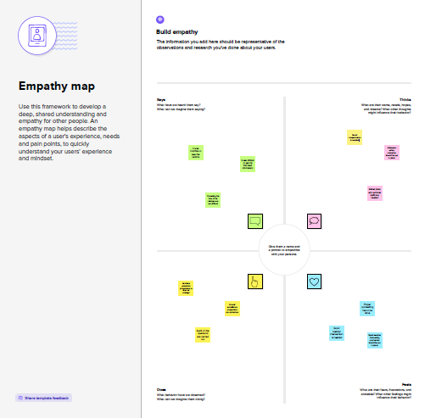

1. 2 Ideation and brainstorming map

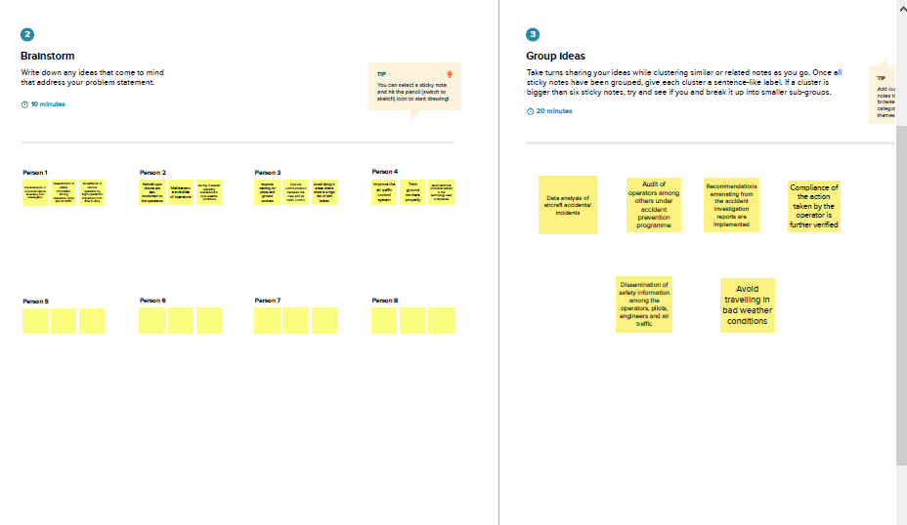

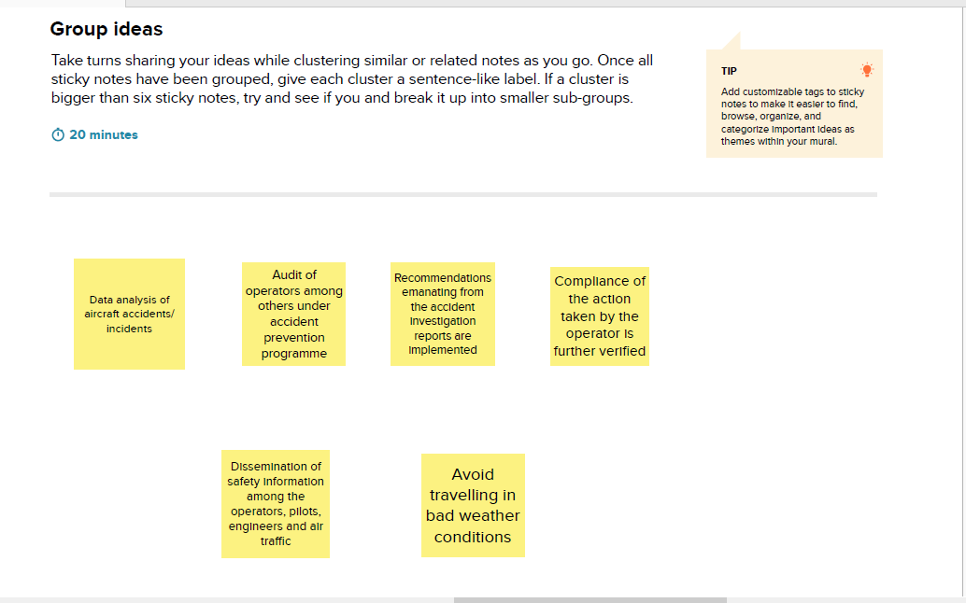

3 RESULT

* Maximum accident happened in the year 1972
* Russia had more number of accidents
* 80% of all aviation accidents can be attributed to human error
* Landing and takeoff are the most complex phases of flight for any airplanes
* General aviation aircraft were involved in almost 78% of all crashes
* Air travel is only as safe as the operator, the equipment and the training procedure that underlie the flight itself

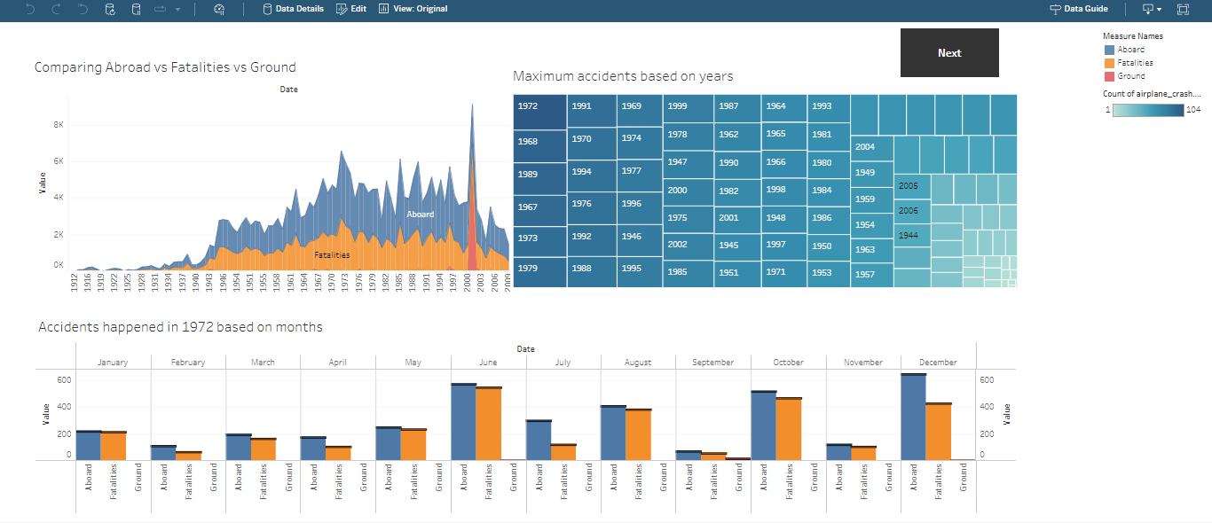

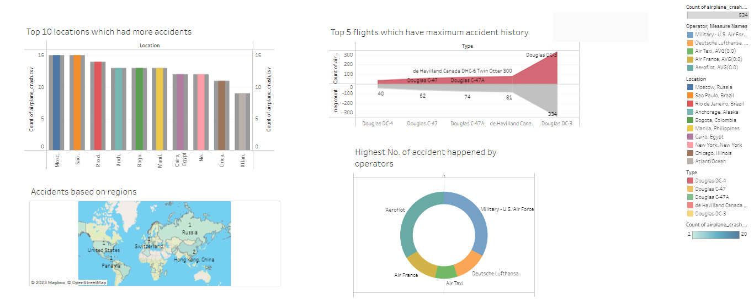

4 ADVANTAGES AND DISADVANTAGES OF AIR TRANSPORT

4.1 Advantages

* High speed
* Fast service
* Send almost everywhere your freight
* High standard of security
* Natural route
* There is less need for heavy packaging
* Most efficient way to travel long distances
* Can carry a lot of weight

4.2 Disadvantages

* It can be expensive depending on the route and season
* You might have to fly early or late
* Security measures can be inconvenient and time consuming
* It can be uncomfortable for long journeys
* The journey can be long if you have stopovers
* Some product limitation
* Capacity for small carriage
* Enormous investment

5 APPLICATION

It is important to note that other factors are always in play

when pilot error occurs. The aircraft, environmental issues, and

organizational issues are a few examples. Investigating an

aviation accident is time-consuming and complex but it is

Important to do it to prevent future accidents.

6 CONCLUSION

An aircraft can fly to any location without seeing any natural

obstacles or barriers. Since customs formalities are easily

compiled. It eliminates the need for more time to seek

clearance. Air travel is used for relief operations during floods,

earthquakes, accidents and famines. So safe air traveling is very

Important.

7 PREVENTION OF FLIGHT CRASH

* Improve training for pilots and ground workers
* Improve communication between the crew and air traffic control
* It is important to have proper maintainance
* Avoid flying in areas where there is high risk of bird strikes
* Improve the air traffic control system
* Train ground workers properly
* Avoid negligence of pilots and staffs
* Avoid traveling in bad weather conditions
* Repair technical problems in the airplane